How the Crust is Deformed
Name: | Period:

What are the three types of Tectonic Plate Boundaries? | Next to each Plate Boundary you listed, use arrows to draw how the plates move relative to each other.
- Type One:

- Type Two:

- Type Three:

- Can you name a fourth type of “boundary” that exists between the Crust and the Mantle underneath? | Answer:

What are the three types of Stress? | - Next to each Stress that you listed, use arrows to show the movement
- Type One:

- Type Two:

- Type Three:

- Can you name a fourth type of “boundary” that exists between the Crust and the Mantle underneath? | Answer:

What is a hanging wall, footwall and a fault plane?
- Hanging Wall: | 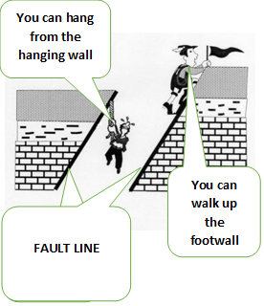
- Foot Wall:

- Fault Line/Plane:

Sketch and define the three MAIN types of faults
- Normal Fault: | Sketch:
- Reverse Fault: | Sketch:
- Strike Slip Fault: | Sketch:
sketch
sketch

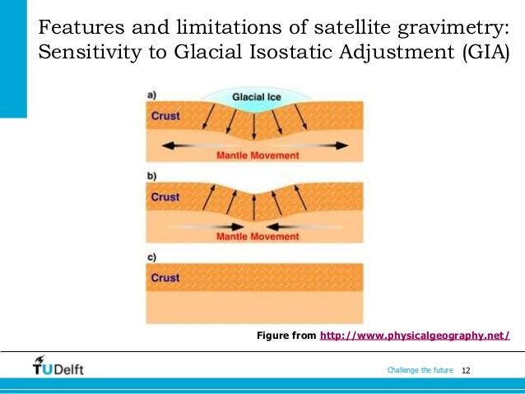 | - Look at the diagram to the left. Describe what is happening in relation to the ice sheet and the crust. (Hint: ISOSTATIC ADJUSTMENT)  Answer:
- 10,000 years ago during our last ice age, glaciers moved as far south as Pennsylvania and Ohio. As glaciers move, their ice carves out deep holes in earth’s crust. As the ice age ended, the glaciers began to melt filling the holes they carved. Five large lakes formed known as the:  (Hint: two words) | 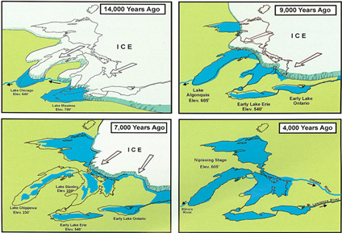
What can you assume is happening to the land/crust where the Great Lakes are located? Why would you assume this?

Answer:

